**Phase 1: Problem Definition and Design Thinking**

**Problem Definition**: The project involves delving into big data analysis using IBM Cloud Databases. The objective is to extract valuable insights from extensive datasets, ranging from climate trends to social patterns. The project includes designing the analysis process, setting up IBM Cloud Databases, performing data analysis, and visualizing the results for business intelligence.

**Design Thinking:**

**1.Data Selection:** Identify the datasets to be analyzed.

The choice of datasets for big data analysis depends on the specific objectives and the domain of interest. For example, datasets that are often used are climate data and social media trends data.

**1. Climate Data:**

–**Description:** Climate data includes a wide range of environmental and meteorological variables that are collected over time to monitor and understand climate patterns and changes. It encompasses data related to temperature, precipitation, wind speed, humidity, atmospheric pressure, sea level, and more.

–**Use Cases:** Climate data analysis is crucial for understanding climate change, weather forecasting, assessing the impacts of climate-related events (e.g., hurricanes, droughts), and informing environmental policies and decisions.

–**Sources:** Climate data is collected from various sources, including weather stations, satellites, ocean buoys, and climate models.

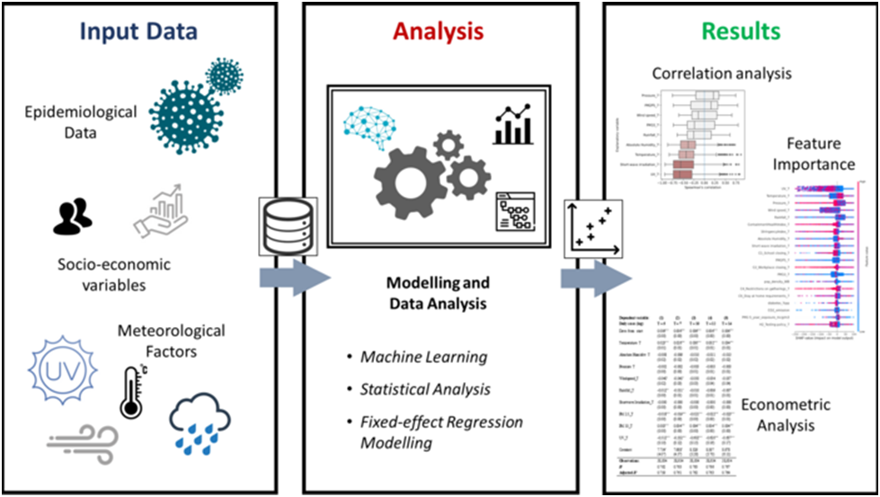

**2.Social Media Trends Data:**

-**Description:** Social media trends data consists of information extracted from social media platforms like Twitter, Facebook, Instagram, and LinkedIn. It includes text data from posts, comments, and tweets, as well as metadata such as user profiles, likes, shares, and timestamps.

-**Use Cases:** Social media trends analysis is employed for sentiment analysis, tracking public opinion, monitoring brand mentions, identifying emerging trends, and understanding user behavior and preferences.

-**Sources:** Data from social media platforms can be obtained through APIs provided by the platforms themselves or through web scraping techniques.

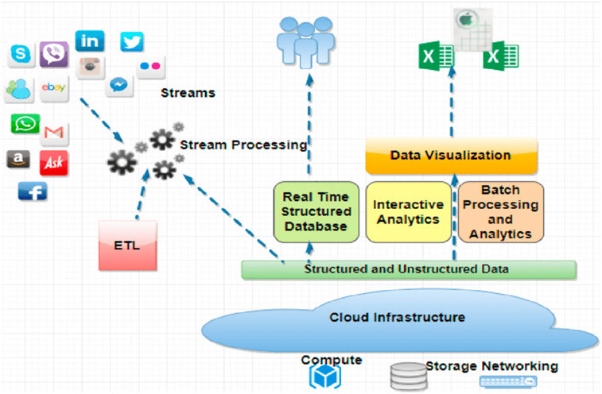

**2. Setting up Database:**

Setting up a database in IBM Cloud involves several steps, and the exact process may vary depending on the type of database service you want to use. Here's a general overview of how to set up a database in IBM Cloud:

**1. Sign In to IBM Cloud:**

- If you don't already have an IBM Cloud account, sign up for one.

- Log in to your IBM Cloud account using your credentials.

**2. Access the IBM Cloud Catalog:**

- From the IBM Cloud dashboard, access the "Catalog" or "Create Resource" section. This is where you can browse and select the database service you need.

**3. Select a Database Service:**

- Browse the catalog to find the type of database service you want to set up. IBM Cloud offers various database options, including Db2, Db2 Warehouse on Cloud, and more.

**4. Configure the Database:**

- Once you've chosen a database service, you'll need to configure it. This involves specifying details like the service plan, region, and any additional settings or features you require.

**5. Create the Database Instance:**

- After configuring the database, you can create an instance of the database service. This instance will be where your data is stored and managed.

**6. Access and Manage the Database:**

- Once the database instance is created, you'll typically have access to a management console or dashboard where you can perform actions like creating tables, importing data, and managing security settings.

**7. Load Data and Perform Operations:**

- With your database instance set up, you can start loading data into it and performing database operations as needed. This might involve SQL queries, data imports, and creating schemas.

**3.Data Exploration:**

Data exploration techniques used in IBM Cloud Databases for climate data and social media trends data involve a combination of SQL queries, statistical analysis, data visualization, and machine learning.

**1. SQL Queries (Structured data - Climate Data):**

* **Aggregation:** Calculate summary statistics like averages, minimum, maximum, and counts for temperature, precipitation, or other climate variables by location, date, or time intervals.
* **Filtering:** Extract specific subsets of data, such as data for a particular location, time period, or extreme weather events (e.g., hurricanes, heatwaves).
* **Join Operations:** Combine climate data with other relevant datasets, such as geographical data or historical climate records, for comprehensive

analysis.

**2. Natural Language Processing (NLP) and Text Analysis (Semi-Structured Data - Social Media Trends):**

* Sentiment Analysis:
* Topic Modeling

**3. Data Visualization:**

* Time Series Plots
* Geospatial Visualization
* Word Clouds:

**6. Continuous Monitoring and Alerting:**

* Set up automated monitoring and alerting systems to detect significant changes in climate data or emerging trends in social media discussions related to climate.

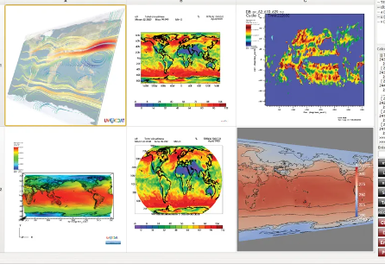

**4. Analysis Techniques:**

Statistical analysis of climate trends and social media patterns in the context of big data requires specialised techniques and considerations. Here are some statistical analysis techniques tailored to these specific domains:

**Climate Trend Analysis:**

**1. Time Series Analysis:**

* · Analyze historical climate data over time to identify trends and patterns.
* · Techniques include moving averages, seasonal decomposition, and autoregressive integrated moving average (ARIMA) modelling.

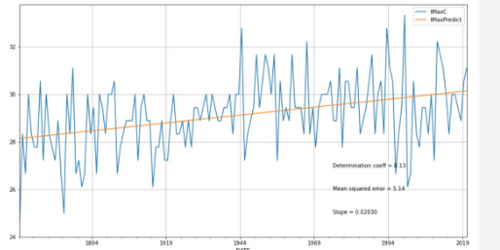

**2. Extreme Event Analysis:**

· Study extreme weather events like hurricanes, droughts, and heatwaves.

**3. Spatial Analysis:**

· Examine how climate variables vary across geographical regions.

· Utilise spatial statistics, geostatistics, and Geographic Information Systems (GIS) to analyze spatial patterns and correlations.

**4. Climate Change Detection and Attribution:**

· Assess whether observed climate changes are consistent with expected trends and human influence.

· Techniques like climate fingerprinting and detection and attribution analysis are used for this purpose.

**5. Machine Learning for Climate Modeling:**

· Apply machine learning models to climate data for prediction and modelling.

· Techniques include deep learning, ensemble models, and regression models for climate modelling and forecasting.

**Social Media Pattern Analysis:**

**1.Social Network Analysis (SNA):**

–Investigate relationships and interactions among users in social networks.

–Calculate network metrics (e.g., centrality, clustering coefficient) to understand network structures.

**2.User Behavior Analysis:**

–Analyze user behaviors, such as posting frequency, engagement, and click-through rates.

–Use statistical techniques to identify user segments and behavioural patterns.

**3.Deep Learning for Image and Video Analysis:**

–For platforms like Instagram and TikTok, apply deep learning techniques to analyze images and videos, including image classification and object detection.

**4.Visualization:**

Creating effective visualisations for the project for climate trend analysis and social media pattern analysis requires thoughtful consideration of the data, audience, and goals. Below are some visualisation ideas for presenting analysis results in an understandable and impactful manner:

**1. Climate Trend Analysis:**

**a. Time Series Plots:**

Create line charts to display temperature or precipitation trends over time. Use different colours to represent different regions or cities, and include trend lines to highlight patterns.

**b. Heatmaps:**

Generate heatmaps to visualize temperature anomalies or trends across a geographic area. This can help identify regions with significant temperature variations.

**c. Bubble Charts**:

Create bubble charts that represent climate data for different cities or regions. The size of the bubbles can indicate the severity of temperature or precipitation changes.

**2. Social Media Pattern Analysis:**

**a. Word Clouds:**

Generate word clouds to visualize the most frequently used words or hashtags in social media posts related to the project. This can help identify popular topics or trends.

**b. Network Graphs:**

Build network graphs to visualize relationships between users or topics in social media conversations. Nodes can represent users or keywords, and edges can represent interactions or associations.

**c. Time-Stamped Streamgraphs**:

Use stream graphs to display the volume and sentiment of social media posts over time. Each stream represents a sentiment category, and the width of the stream corresponds to the volume of posts.

**5. Business Insights:**

Interpreting the analysis findings from the project for climate trend analysis and social media pattern analysis can provide valuable business intelligence and actionable recommendations. The key findings and insights from each analysis and provide recommendations for businesses or organisations involved in these areas are as follows:

**Climate Trend Analysis:**

**Findings and Insights:**

**a. Temperature Trends:**

The analysis reveals a consistent increase in global temperatures over the past few decades. This indicates a clear pattern of global warming, which can have significant environmental and economic impacts.

**b. Regional Variations:**

Different regions exhibit varying temperature trends. Some areas may experience more rapid warming than others, which could lead to localized climate challenges.

**c. Extreme Weather Events:**

The data suggests an increase in the frequency and severity of extreme weather events, such as hurricanes, droughts, and heatwaves. These events can disrupt supply chains, impact infrastructure, and increase business risks.

**Actionable Recommendations:**

**a. Sustainability Initiatives:**

Businesses should consider adopting sustainability initiatives to reduce their carbon footprint and mitigate the effects of climate change. This can involve energy-efficient practices, renewable energy adoption, and waste reduction.

**b. Risk Assessment:**

Conduct a thorough risk assessment to understand how climate trends may affect the business. This includes evaluating supply chain vulnerabilities and the resilience of physical assets to extreme weather events.

**c. Data-Driven Decision-Making:**

Continue to monitor climate data and trends. Use predictive analytics to anticipate potential climate-related disruptions and make informed decisions to safeguard operations.

**Social Media Pattern Analysis:**

**Findings and Insights:**

**a. Sentiment Analysis:**

Social media sentiment analysis reveals that public sentiment about the project and its related topics is generally positive. However, there are occasional spikes in negative sentiment, often related to controversies or incidents.

**b. Influencers:**

Certain individuals or organizations have a significant impact on shaping the conversation about the project. Identifying and engaging with these influencers can help control the narrative and garner support.

**Actionable Recommendations:**

**a. Engagement Strategy:**

Develop a proactive social media engagement strategy to maintain a positive public perception. Respond promptly to concerns and leverage positive sentiment to build support for the project.

**b. Monitoring and Alerts:**

Implement social media monitoring tools that provide real-time alerts for spikes in negative sentiment or emerging issues. This allows for swift response and issue mitigation.

**d. Content Strategy:**

Create content that aligns with popular topics and hashtags to engage the audience. Content should be informative, visually appealing, and shareable to increase visibility.